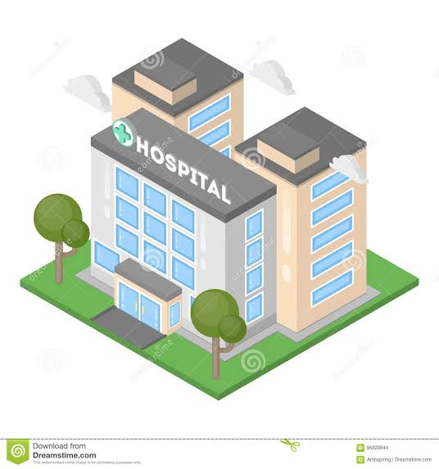

**HOSPITAL MANAGEMENT SYSTEM**

**SYSTEM REQUIREMENT SPECIFICATION**



***Bachelors in Computer Science***

**Class ID:** *103743*

**Student ID:** *9729*

**Student Name:** *Fizra Azhar*

**Student ID:** *9295*

**Student Name:** *Ayesha Rahim*

**Instructor Name:** *Sir. Sohail Imran*

**Course Name: *Object Oriented Analysis and Design***

# *Acknowledgement*

#### This SRS is the result of a class assignment carried out by RMU’s Fall 2014 class of ENGR3410

* Fundamentals of Software Engineering under the supervision of Dr. S. Acharya. Appreciation goes to all the members of this class listed below:

1. ***INTRODUCTION:***
   1. **) PERPOSE:**

This document will define all features and procedures to develop the system. The purpose of the Hospital Management System (SHMS) is to create a Free and Open Source Software (FOSS) Hospital Management System. This project is being developed mainly for our client, Appalachian Health Network (AHN), but will be extensible enough to be adapted and customizable for deployment and integration into any hospital network. The SHMS contains five distinct sub-systems:

• Radiology Information System (RIS)

• Picture archiving and Communication System (PACS)

• Image Acquisition Modality System (IAM)

• Admit-Discharge-Transfer/Patient Registration System (ADT/PRS)

• Hospital Management Systems (HIS)

* 1. **DOCUMENTATION CONVENTIONS:**

This document will use IEEE format. For clarity, acronyms and technical jargon, deemed uncommon by the author, will be annotated and included in the glossary. The format for headings is as followed: Major headings are in bold 18pt font, and concurrent headings in bold 14 pt font. Sections are in the format of x.y, where x and y are real, positive integers.

**2.3) INTENDED AUDIENCE AND READING SUGGESTIONS:**

This Software Requirements Specification document is intended for software engineers, system testers and software designers in developing, testing, and producing the SHMS and for the project. It is suggested to read the sections sequentially, and to reference the appendices as one progresses, in order to clarify jargon terms and definitions.

* 1. **SCOPE AND LIMITATIONS:**

This SRS details the development of the Hospital Management System project and the five subsystems. This project is open source and shall be available to modification at no restriction from Inc. Inc. is not responsible or liable for any changes made to this project outside of its initial release. The scope of the RIS subsystem is to create a generic FOSS RIS program, which can be customized for deployment and integration into any hospital’s use; however, once developed, the RIS will be customized to the needs of our client, Allegheny Health Network. The PACS scope is to create an archive and communication system that covers how medical pictures are gathered, stored, shared amongst medical professionals, and secured for confidentiality. The scope of the IAM subsystem is to create a system that shall control all image acquisition devices processed by a hospital. The desired system combines several different software controlling systems into one system capable of running numerous types of imaging devices, further reducing training time and creating a more efficient imaging department. The HIS scope is to assist privileged users to make decisions needed for health or financial issues relating to the patients in the database. This subsystem shall also provide the users with organization and access to easy accurate information. The ADT/PRS subsystem is to streamline the process of handling patient data. A patient’s information is store and share with the appropriate people automatically under this subsystem.

1. ***PROJECT ORGANIZATION:***

***8 | H o s t e l M a n a g e m e n t s S y s t e m
1.2) Project Organization (The team):
1.3) Schedule:
Job Title Descripti...***

1. ***Project Schedule:***

8 | H o s t e l M a n a g e m e n t s S y s t e m
1.2) Project Organization (The team):
1.3) Schedule:
Job Title Descripti...

1. ***Hardware and Software Cost and Requirement:***

9 | H o s t e l M a n a g e m e n t s S y s t e m
1.4) Hardware and software Cost and Requirements:
Hardware Cost and Requ...

1. ***Project Management Approach:***

**6.1. Software Process Model:**

To solve the actual problem in an industry, software developer or a team of developer’s must integrate with a development strategy that include the process methods and tool layer and generic phases. The strategy is often referred to a process model or a software developing paradigm.

* 1. **Our system follows Waterfall model.**

1. Requirement definition.
2. System and software design.
3. Implementation.
4. Integration and system testing.
5. Operation and maintenance.

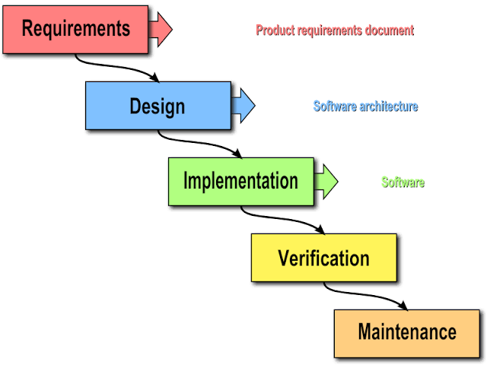

1. ***Overall Description***

**7.1. Product Perspective:**

The Hospital Management System is an open source system comprising of five different subsystems. The five subsystems are as follow: The FOSS RIS project is a separate program, which is a component of a larger FOSS Hospital Management System (HMS), similar to how Microsoft Word is a separate program inside Microsoft Office suite. In the FOSS HMS system, the FOSS RIS program performs all HIS operations. The RIS module uses the shared, global variables, enemas, framework, and used to create the other FOSS HIS program components, just like with Microsoft Office. All data exclusive to the RIS module will be programmed in the RIS module. Hospital Information System will replace all traditional and outdated means of tracking patient information and other data useful to the hospital. A Hospital Information System shall replace forms of databases using manual or outdated hardcopy databases. Accessing data can be better monitored, organized, and time conscientious. The IAM program shall be a new management system which shall make individual systems obsolete. It shall allow one program to control all the different image acquisition devices and shall interact with the other components of the hospital management system being designed. The driving principle of this PACS is to automate and provide the infrastructure to digitally control the storage and transportation of images taken with compatible devices within a general hospital. The ADT/PRS subsystem stores patient data, which other subsystems can access as required. This is accomplished by granting the other systems access to this subsystem’s patient database.

* 1. **Product Features:**

The SMS has five subsystems and these subsystems shall perform the following features:

• The RIS subsystem shall include patient list management, radiology department workflow management, request and document x-ray scanning, result entry, and reporting and printout/faxing and emailing of clinical reports.

• The PACS subsystem shall perform image importing/capturing, image encryption, local image storage, remote image retrieval, image compression, image display, and image processing.

• The HIS subsystem shall contain a secure database. The database GUI shall be user friendly for all staff members and properly enter/obtain/modify patient information. The DB shall utilize the token authentication for secure access and will be relative in size and flexibility of the data demand.

• The IAM subsystem shall have a simple user interface which allows the user to log in then access any imaging device connected to the imaging intranet, select what type of device and then which specific device within the hospital they will use. The images shall be controlled from one console and share these images with the hospital patient database.

• The ADT/PRS subsystem shall allow an administrator to enter patient information, such as name, age, etc. That information is then stored, and shared with other users as appropriate. It shall also alert the medical staff when a patient that requires different treatment is admitted, such as some with an infectious disease.

* 1. **User Classes and Characteristics:**

The entire FOSS SMS suite program has a set of users, each with different security privileges. These user types are head doctor/nurse, and doctor/nurse. The head doctor/nurse can control most of the system, can transfer data in/out of hospital networks and to other doctors/nurses who need the patient’s medical information from the patient database, and possesses read/write permissions on sending/receiving data to/from the database. The head can also control the PACS subsystem and the ADT/PRS subsystem. The doctor can receive data in/out of a health network from the database with permission from a head doctor/nurse, but the data is read-only. If changes or updates need to be made on the data, the doctor/nurse must put in a request with the head doctor/nurse to make the changes to the database. This is the same for the ADT/PRS subsystem, where only the administrator can enter/edit data. All access and data transfers/receiving is logged, in order to maintain a level of transparency, in order to prevent abuse of the system, and in order to hunt down any unauthorized users or Software Requirements Specification for Hospital Management System Page 3 hackers. This logging is done by the software logging each function call along with its parameters being passed, as well as the current user logged on who performed them.

* 1. **Operating Environment**:

The FOSS SMS program runs on Windows 7, for 32-bit/x86 and 64-bit/x64 PC architectures. The software for the RIS subsystem will be written in C#, using Microsoft Visual Studio 2010. The program will be GUI-based (like with most modern Windows software). The HIS subsystem will run off a Cloud-Based Platform. The Cloud-based server will utilize Oracle or SQL database running on the cloud. The operating system shall be a MS-Windows or UNIX. Integration to the server shall be done via a HTTPS, SFTP, or VPN to create, update, fetch, or delete data.

* 1. **Design and Implementation Constraints:**

Items and issues that may limit the options available to the software developers are legal and ethical constraints with regard to SHMS development and medical practices, and possible social and legal opposition by HIS corporations who loathe FOSS software. Moreover, parallel threads will need to take place in the larger HIS operation, which will require research in how to program and operate with several, parallel-running threads in the same application. Constraints of the user-permissions system specified in §2.4 must be programmed, for the database system. This project shall implement a series of subsystems that shall contain sensitive medical and personal records. Due to this, security features and login fail safes shall be of the highest concern when developing this project. Such security features include high-security of data transfers, and encrypted network communications, as well as programming logging of function calls as well as parameters passed. It is anticipated that all related governing directives both social and governmental regulations will be adhered to; thus in accordance with The Health Insurance Portability and Accountability Act of 1996 (HIPAA), access to images will be strictly enforced by the Authentication Module. Encryption will be employed to keep health information secure, but may impose a processing overhead that can potentially hinder timing requirements Due to the large nature of the project, keeping track of the source code between the developer sub-teams will be difficult. We plan to implement a subversion/source control system, most likely Github, where we will pull/push code commits to/from the Github server. The source code, as well as the current folder/file structure, will be able to be uploaded and fetched from our Github account. Once completed, the software will be continuously updated by the developers, and major upgrades to the system can be downloaded from our website, Softright.com, as service packs. Smaller bug fixes can be downloaded as hotfixes, also available for download from the website. Updates can be discovered by manually browsing our website, or by pulling down the help tab, which has a “Check for Updates…” feature.

* 1. **User Documentation:**

The application will come with an “About” tab, which will allow users to access the offline and online HTML .hlp help manual. This manual will be updated with each new service pack. Other user documentation includes one user manual for lowest level users, one technical document describing the functionality of the subsection in detail for use of technicians, one copy of documentation and link to current source for future contributors.

* 1. **Assumptions and Dependencies:**

The developers, assume that we will have to “pave our own way” concerning programming the majority of the application, due to the mostly closed-source and secretive nature of major SHMS software. For what we cannot find from open documentation and research, it is assumed that we will have to deduce how HIS standards and protocols work from observing external behaviors found in existing HIS software, and we will have to replicate the results using our own code and other FOSS applications and libraries. It is assumed that social and legal opposition by money-hungry HIS corporations who loathe FOSS software could occur. The project will Software Requirements Specification for SoftRight Hospital Management System Page 4 have to depend on FOSS SQL database libraries, 7zip .7z compression libraries, OpenTLS libraries, TCP/IP libraries, and other FOSS libraries, in order to keep this software free of proprietary libraries, in order to keep the software in a FOSS status. This project is developed under the working assumption that as an open source project it shall be noted that the project shall change overtime. Regular changes to this SRS shall occur for each change enacted by SoftRight Inc. It is assumed that the PACS will be used in a Hospital Environment by untechnical users. It is assumed that the infrastructure for capturing digital images in either .JPG, .GIF, .DICOM, etc will exist. It is assumed that the System will be networked, and capable of routing to an internet gateway.

# *SYSTEM FEATURES:*

## System Architecture:

## 13 | H o s t e l M a n a g e m e n t s S y s t e m (4) User Requirements Definition: The user requirement for this system ...

## Radiology Information System

### *Patient Registration and scheduling*

* + - * 8.2.1.1 Description and Priority

This is the feature which registers patients and schedules appointment for X-Rays. It will allow the user to pull up the list of existing patients and edit data in an Excel-like spreadsheet database, schedule and view appointments from a calendar, and push/pull that data to/from the database, with head doctor permission. An email will be sent to the patient, reminding him of his appointment.

* + - * 8.2.1.2 Functional Requirements

R-PRS-1: User shall pull up list of existing patients via dialog box

R-PRS-2: User shall be able to add/remove/edit (with permission) patient information from Excel-like spreadsheet database

R-PRS-3: User shall be able to schedule patients for X-Ray appointments

R-PRS-4: Doctor shall be able to transfer/receive data to/from the database, after making request to Head Doctor

R-PRS-5: Software shall send email to patient reminding them of their appointment R-PRS-6: All offline and online actions shall be monitored by the software’s logging

feature, in order to maintain transparency and to minimize risk/abuse of the system.

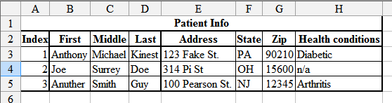

### Patient Database

### *Radiology Department workflow management*

* + - 1. Description and Priority:

This feature allows the radiology department to schedule, list, and cross off work tasks in a to-do list.

* + - 1. Functional Requirements:

R-RWM-1: Doctor shall be able to receiver/transfer work tasks to/from the workflow database

R-RWM-2: Doctor shall be able to send request of adding info to the Head Doctor

R-RWM-3: Head Doctor shall be able to dis/approve adding/crossing off work from the workflow database

R-RWM-4: Doctor shall be able to request crossing off tasks from Head Doctor

R-RWM-5: All offline and online actions shall be monitored by the software’s logging feature, in order to maintain transparency and to minimize risk/abuse of the system.

### *Request and document X-Ray scanning*

* + - 1. Description and Priority

This feature allows the radiology department to request x-ray scanning, which will then be sent to the Image Acquisition Module (IAM), and to keep and manipulate the image files of the x-rays.

* + - 1. Functional Requirements

R-XRAY-1: Doctor shall be able to send request of patient’s x-ray to the Head Doctor R-XRAY-2: Head Doctor shall be able to dis/approve the x-ray

R-XRAY-3: Head Doctor will send his dis/approval of x-ray to radiology technicians, and to the IAM

R-XRAY-4: With the IAM, the RIS shall be able to retrieve the raw data of the x-ray, create and image, and store/edit it in the database

R-XRAY-5: All offline and online actions shall be monitored by the software’s logging feature, in order to maintain transparency and to minimize risk/abuse of the system.

### *Result entry*

* + - 1. Description and Priority

This feature allows the doctor to store the results of the x-ray (how is the bone/body part damaged, if at all), etc.

* + - 1. Functional Requirements

R-ENTRY-1: Doctor shall be able to send/receive the x-ray images to the head doctor, as well as bone result

R-ENTRY-2: Head Doctor shall be able to dis/approve the results, and allow the data to be pushed to the database

R-ENTRY-3: All offline and online actions shall be monitored by the software’s logging feature, in order to maintain transparency and to minimize risk/abuse of the system.

### *Reporting and printout*

* + - 1. Description and Priority

This feature allows the reporting and printing out of x-ray results and images. Printouts will be able to interface with the hospital institution’s network printers, and PDF files will be generated using a virtual PDF printer driver, rather than the development team wasting time in reinventing the wheel.

* + - 1. Functional Requirements

R-RPT-1: Doctor shall be able to generate digital PDF reports via PDF printer driver R-RPT-2: Doctor shall be able to send request of documents to Head Doctor, who will

dis/approve of it, and push the data to the database, as necessary

R-RPT-3: Doctor shall be able to physically printout x-ray images and reports, and email/fax the data

R-RPT-4: All offline and online actions shall be monitored by the software’s logging feature, in order to maintain transparency and to minimize risk/abuse of the system.

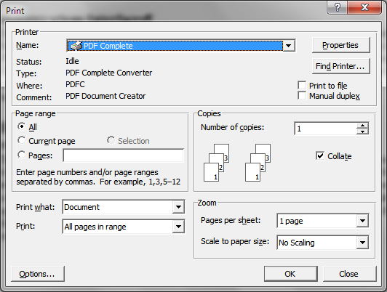

### Virtual PDF printer driver

Converts whatever would be printed into a PDF file

## Picture Archiving and Communication System

### *Authentication*

* + - 1. Description and Priority

This feature will ensure only authorized users gain access to stored images. This feature is considered a High Priority. Failure to provide this feature will likely incur legal costs.

* + - 1. Stimulus/Response Sequences

The User launches the Application, a Login screen appears.

The User enters a username and password pair, the Authentication Module authenticates the pair. The Authentication Module returns false, the User is prompted to retry.

The Authentication Module returns false three times in a row, the Application terminates. The Authentication Module returns true, the User is granted access to the PACS GUI. The username and password pair is not valid, the Authentication Module returns false.

The username and password pair is valid, the Authentication Module returns true.

The User registers an account, the System Administrator receives an email detailing admittance procedures.

The System Administrator allows access, the username password pair is valid.

The System Administrator denies access, the username password pair is invalid and the user is sent an email.

* + - 1. Functional Requirements

R-AUTH-1: The user shall only be granted access if the username and password par are valid.

R-AUTH-2: The Authentication Module shall send an email to the System Administrator of registration requests and invalid login Application terminations.

### *Image Viewer*

#### Description and Priority

This feature will enable the loading onto screen of images and will allow the user to perform panning and zooming of the display area. High Priority. Failure to provide this feature will render the System unusable.

#### Stimulus/Response Sequences

The User imports an image, the Image Compression/Encryption Module loads the image into memory and displays the image on the screen.

The User saves an image, the Image Compression/Encryption Module Encrypts the image, compresses it, and saves it to the local persistent memory.

The User loads an image, the Image is loaded into memory and displayed on the screen.

The User pans the current image, the image area being displayed changes according to the offset. The User zooms in/out the image, the area of the image is magnified, reduced.

* + - 1. Functional Requirements

R-IMVW-1: An image shall load into memory when the User imports a valid and supported format.

R-IMVW-2: An image shall load into memory when the User opens a saved image. R-IMVW-3: A saved image will not be accessible from outside of the image viewer.

R-IMVW-4: An image may be exported to either: PDF, JPEG, DICOM, BMP or PNG, etc. only after the User agrees to an HIPAA disclosure.

R-IMVW-5: An image must load and be displayed on screen to within 300<may be reduced after further testing> ms / MB from the time the image was opened.

R-IMVW-6: A minimum of four images shall be able to be tiled on screen to accommodate before and after diagnoses.

R-IMVW-7: An image shall update when the user pans/zooms the image.

R-IMVW-8: Image statistics and meta data shall be able to be displayed on the screen at the same time as a minimum of four tile images. Maximum shall be defined by the hardware limitations.

### *Image Compression/Encryption Module*

* + - 1. Description and Priority

The image compression and encryption module will be essential to the security and economical storage of the images. Once imported into the PACS, the images will require proper authentication to view.

* + - 1. Stimulus/Response Sequences

The User saves an image, the image is compressed, then encrypted and stored on the cloud.

* + - 1. Functional Requirements

R-CRYPT-1: The system shall be able to reload an image from an archived image. R-CRYPT-2: The system shall be able to encrypt the images.

## Image Acquisition Modality System

### *Login screen*

* + - 1. Description and Priority

This shall be required before every imaging process. The user, upon opening the application, and with every successive image capturing request after, is prompted to enter their hospital employee ID. This is a high priority for completion.

* + - 1. Stimulus/Response Sequences

The user shall type in their ID and clicks continue. If their ID is correct and acceptable the application shall open to the home screen

* + - 1. Functional Requirements

R-LOGIN-1: The software must interact with an employee database which can confirm the ID is an employee of the hospital and approved to use this software.

### *Home page*

* + - 1. Description and Priority

This will be the main page of the application. At the top there will be ribbons very similar to those seen in Microsoft Office products. Each ribbon will be for a specific type of imaging machine. There will also be a ribbon for sharing captured images with the hospital patient database, as well as a settings tab.

* + - 1. Stimulus/Response Sequences

Users shall click on the tab for their desired imaging machine. They shall then be prompted to enter the machine ID into the system. Upon selecting a valid machine they will be able to access all commands associated with its imaging systems.

### *Acquiring Image*

* + - 1. Description and Priority

This feature will acquire images from any kind of hardware the hospital uses, such as x-rays and CT scans.

* + - 1. Stimulus/Response Sequences

This feature will be stimulated by the hardware (x-rays), and it will receive the image data from it.

* + - 1. Functional Requirements

R-ACQIM-1: Software shall acquire image data from hardware.

### *Processing Image*

* + - 1. Description and Priority

This feature will correctly process the image data previously gathered and prepare image for display

* + - 1. Stimulus/Response Sequences

This feature will be stimulated by the previous feature: “Acquiring Image”. After that process is done, it will send the data to this feature and then it will process the image.

* + - 1. Functional Requirements

R-PROC-1: Software shall collect data from previous feature. R-PROC-2: Software shall process image

R-PROC-3: Software shall prepare image for display

### *Displaying Image*

* + - 1. Description and Priority

This feature will display the image to any compatible hardware in the hospital.

* + - 1. Stimulus/Response Sequences

This feature will be stimulated by the previous feature: “Processing Image” and it will respond by displaying the image.

* + - 1. Functional Requirements

R-DISP-1: Software shall collect data from previous feature R-DISP-2: Software shall display Image

## Admit-Discharge-Transfer/Patient Registration System

### *Admission*

* + - 1. Description and Priority

This feature shall allow users to admit a patient into the care of a health professional collecting information about said patient. It shall record the patient’s symptoms and assign them a room and doctor based on their condition. It shall include also include search, edit, and print report features.

* + - 1. Stimulus/Response Sequences

This feature shall be a screen with various inputs pertaining to the patient and their condition. There shall be text fields for the patient’s information such as name, date of birth, address, social security number, insurance information, height, weight, etc. The user shall then chose whether the patient shall be inpatient or outpatient, and if they are inpatient they shall choose a room from a list of available rooms. The user must fill out the form and finalize all information. Once sent, the database will refresh with the newly entered information. Based on the patient conditions, the system will automatically assign them an appropriate doctor with the proper specialization to deal with the patient's ailment.

* + - 1. Functional Requirements

R-ADMS-1: The ADT system shall have a User Interface to collect, edit and print patient data

R-ADMS-2: The ADT User Interface shall have data fields for the following patient information:

SSN, First Name, Last Name, Other Name, Age, Sex, Date of Birth, Phone, Street Address, City, State, Zip, Referring Doctor’s Name, Referring Doctor’s Phone number, Pharmacy Name, Pharmacy Location, Pharmacy Number, Insurance Information

R-ADMS-3: The ADT User Interface shall have data fields for collecting patient height, weight, symptoms

R-ADMS-4: The ADT User Interface shall have data fields for the following patient information:

Inpatient, Outpatient, Room Number, Assigned Doctor

R-ADMS-5: The ADT User Interface shall have a search feature which shall allow patient search by last name + first name and by SSN.

R-ADMS-6: The ADT User Interface shall have an Edit option to change patient information (excluding SSN).

R-ADMS-7: The ADT User Interface shall have a Print function to print selected patient reports.

### *Registration*

* + - 1. Description and Priority

This feature shall allow users to register a patient into the global database. It shall collect all of the patient’s information and previous health records.

* + - 1. Stimulus/Response Sequences

It will be a system separate from the admissions system, but will have a similar look and functionality. This feature shall be a screen with various inputs pertaining to the patient. There shall be text fields for the patient’s name, phone number, date of birth, age, address, social security number, height, weight, etc. The user will also have the option to import past health records if the patient has come from a different hospital. Allows the user to assign special condition codes to patients as well as where the patient should be headed in terms of sections of the hospital (E.R, ICU, etc.)

* + - 1. Functional Requirements

R-REG-1: The PRS system shall have a User Interface to collect, edit and print patient data

R-REG-2: The PRS User Interface shall have data fields for the following patient information:

SSN, First Name, Last Name, Other Name, Age, Sex, Date of Birth, Phone, Street Address, City, State, Zip, Referring Doctor’s Name, Referring Doctor’s Phone number, Pharmacy Name, Pharmacy Location, Pharmacy Number

R-REG-3: The PRS User Interface shall have a search feature which shall allow patient search by last name + first name and by SSN. The search results shall permit the import of patient records from network hospital.

R-REG-4: The PRS User Interface shall have an Edit option to change patient information (excluding SSN).

R-REG-5: The PRS User Interface shall have a Print function to print selected patient reports.

R-REG-6: The PRS User Interface shall register patient with condition codes

### *Transfer*

* + - 1. Description and Priority

This feature shall allow users to transfer a patient to another department or hospital. It shall

compile all of a patient’s records and send them to the new department or hospital. It shall also notify the proper transportation services and the corresponding hospital for this event.

* + - 1. Stimulus/Response Sequences

This feature shall be a screen that displays the patient’s name with a drop down box of all the hospitals and/or departments they may be transferred to. It shall then have a text box for the reason, along with a submission button.

* + - 1. Functional Requirements

R-TRANS-1: Display of patient name

R-TRANS-2: Drop down box of transferrable hospitals R-TRANS-3: Text box for transfer reason

R-TRANS-4: Submit button

R-TRANS-5: Search database for patient

### *Discharge*

* + - 1. Description and Priority

This feature shall allow users to discharge a patient from the hospital. It shall check for their health care provider’s approval first, and then print a packet of information about their visit, any medications they have been prescribed, and any other information necessary.

* + - 1. Stimulus/Response Sequences

This feature shall be a screen that contains a list of all the documents in queue for the patient. The user shall be able to drag and drop any document into the queue to add to it. There shall be a light in the bottom right of the screen where green indicates that they have the doctor’s approval to be discharged, and red means they do not yet have permission.

* + - 1. Functional Requirements

R-DISC-1: List of all documents to be printed

R-DISC-2: Drag and drop feature for additional documents R-DISC-3: Automatic update based on patient’s treatment R-DISC-4: Automatic update based on patient’s medication R-DISC-5: Light to notify approval Y/N

R-DISC-6: Discharge button

## Hospital Management System (HIS)

### *Token Authentication*

* + - 1. Description and Priority

Token Authentication is a more secure means of a login/access than a traditional Username and Password. This is of high priority for the Information System.

### *Secure Connections*

* + - 1. Description and Priority

The connections shall be of a secure means: VPN, HTTPS, or SFTP. The secure connections shall prevent patient information getting into not authorized users/viewers. This is of high priority for the Information System for patient confidentiality.

### *Efficient Database*

3.5.1.1 Description and Priority

The database shall consist of the proper amount of hardware and software for the data demand. This is of high priority for the Information System.

### *User-Friendly GUI*

### 7.5.1.1 Description and Priority:

The GUI for the database shall be user-friendly and shall provide a section for technical support and help. This is of medium priority for the Information System.

### *Technical Support*

The information system shall have electronic assistance for technical issues. This is of medium priority for the Information

1. ***SYSTEM DESIGN:***

The diagram represents what are the boundaries and scope of the system. It describe the main objective of the system and the entities involved

18 | H o s t e l M a n a g e m e n t s S y s t e m
3.1) Introduction:
In this chapter we are introduce Use Case diagram, H...

**9.1. USE CASE DIAGRAM:**

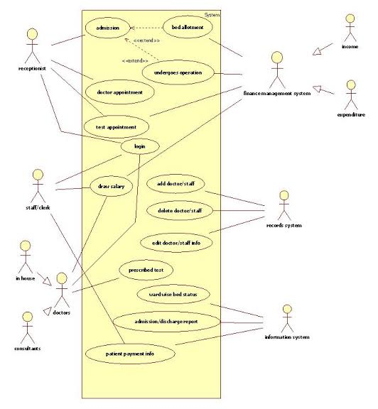

**8.2. SEQUENCE DIAGRAM:**

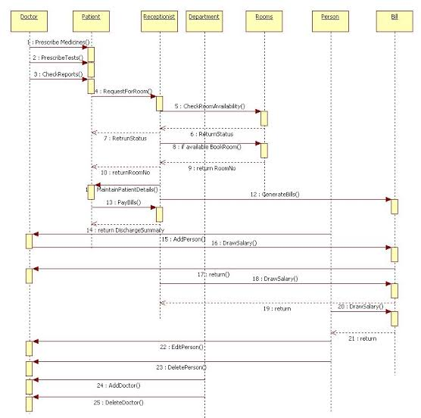

**8.3. ACTIVITY DIAGRAM:**

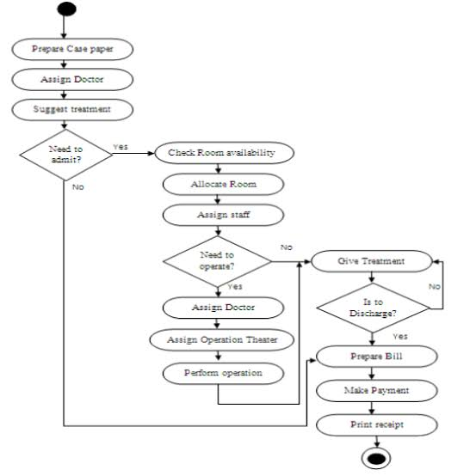

**8.4. CLASS DIAGRAM:**

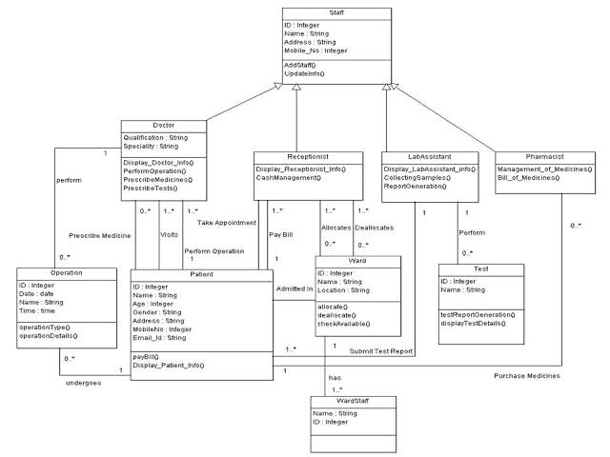

**8.5. Entity relationship Diagram:**

